**DAILY ONLINE ACTIVITIES SUMMARY**

|  |  |  |  |  |  |  |  |  |
| --- | --- | --- | --- | --- | --- | --- | --- | --- |
| **Date:** | **16/06/2020** | | | | | **Name:** | **Manish B Shriyan** | |
| **Sem & Sec** | **8th sem B sec** | | | | | **USN:** | **4AL16CS131** | |
| **Online Test Summary** | | | | | | | | |
| **Subject** | | **BDA** | | | | | | |
| **Max. Marks** | | **30** | | **Score** | | | **26** | |
| **Certification Course Summary** | | | | | | | | |
| **Course** | **Learn Software Testing** | | | | | | | |
| **Certificate Provider** | | | **Eduonix** | | **Duration** | | | **4 Hours** |
| **Coding Challenges** | | | | | | | | |
| **Problem Statement:**  **Write C program for reverse the bits** | | | | | | | | |
| **Status: Solved** | | | | | | | | |
| **Uploaded the report in Github** | | | | | **Uploaded** | | | |
| **If yes Repository name** | | | | | **ManishShriyan** | | | |
| **Uploaded the report in slack** | | | | | **Yes** | | | |

Online Test Details:

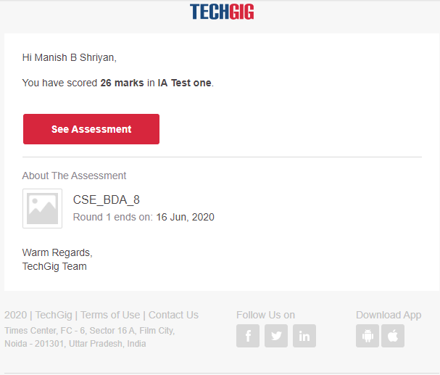

Certification Course Details:

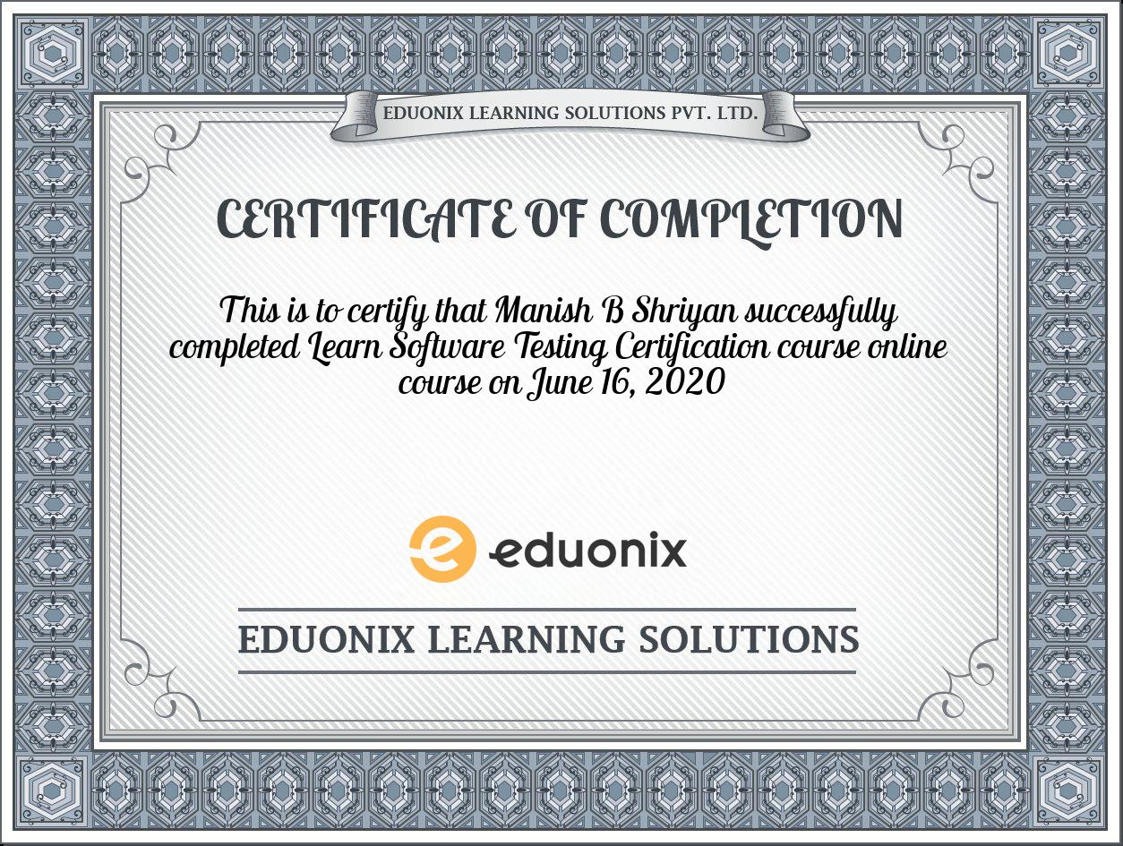

Coding Challenges Details:

|  |
| --- |
|  |
|  |  |
|  |  |
|  |  |
|  |  |
|  |  |
|  |  |
|  |  |
|  |  |
|  |  |
|  |  |

**#include<stdio.h>**

**unsigned int reverseBits(unsigned int n)**

**{**

**unsigned int rev = 0;**

**while (n > 0)**

**{**

**rev <<= 1;**

**if (n & 1 == 1)**

**rev ^= 1;**

**n >>= 1;**

**}**

**return rev;**

**}**

**int main()**

**{**

**unsigned int n = 213;**

**printf("%d", reverseBits(n));**

**return 0;**

**}**

**ts(list1, N)**